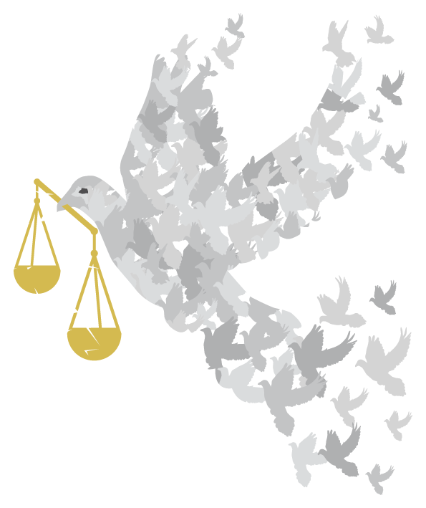

PLEDGES
to build an inclusive society

PLEDGES to build an inclusive society
Think about what is important to you,
and how you can do what you can
to make our world just and peaceful for everyone to live in.

Solemn, binding promises to do, give, or refrain from doing something

How can I use this resource?
You can use these pledges to encourage people to think about how we can build a culture of inclusion, in confident communities of good neighbours that welcome the stranger and celebrate the contribution of all its members; an inclusive society where we can work together to ensure justice and that by taking action, especially action together, we can challenge injustice and build a fairer more peaceful world, fit for all our children to live in.
Possible activities:
- You could separate the pledges from the reasons, and ask people to match them back together. To add a competitive element, people could work in teams, with the first team to complete the task correctly winning a small prize.
- Put all of the pledges into a ‘Pledge Box’ and take it in turns to pick one out. Discuss how the pledge could be implemented.
- Use the dove template (on pages 8 & 9) to make cards with pledges on one side and the reasons on the other or offer blank ones for people to write their own.
- Use Velcro or Blutac to attach them to a board or window making the shape of the dove logo on the cover to symbolise people coming together as a movement.
- Make “Hands of Friendship” (you could get people to draw round their own and cut them out) to write pledges on and display them on a string of linked hands.
- Or put them (on cards, or doves, or hands) on a table for people to choose one that they will take home and try to implement. Printed from these sheets, they can be cut up as strips and folded in half to stand up with the pledge on the front, the reason on the back and space inside for notes as to when the pledge was fulfilled.
- Set up a craft activity to make pledge badges to wear (you could use the smaller version of the dove as template).
- Put your pledge into action and make sure you regularly check how well you are doing. Encourage others to join you, and keep each other motivated.

Why?  Because it is good to know that your savings don’t finance the arms trade or  hold developing world debt. | I pledge to …  Switch to an ethical bank
Why?  Because while the world’s major religions advocate peace, people’s perception is increasingly that religion is the cause of violence. Greater understanding decreases suspicion and increases friendship, unity and solidarity. | I pledge to …  Converse with someone from a different faith or culture  to myself
Why?  Because it develops understanding relationships, forges a sense of community and makes us feel part of where we live.  We can look out for each other, so everyone worries less and has greater personal peace. | I pledge to …  Talk more to my neighbours
Why?  Because praying for peace can be a powerful and positive experience and all faiths teach the importance of peace. | I pledge to ...  Pray for peace at the personal, local and global levels
Why?  Because if everyone can follow this example we will all be treated with love, kindness and respect, and this will bring peace and harmony to the world. | I pledge to ...  Try to do only to others what  I would have done to myself
Why?  Because fair trade means a better deal for the producers, allowing them to feed and  educate their families, access healthcare  and develop their communities,  bringing peace to those around them. | I pledge to …  Keep buying Fair Trade products
Why?  Because other crops are sprayed by polluting insecticides which not only damage the environment but communities nearby. Environmental destruction and land grabs make people homeless and force them to migrate. The International Criminal Court is now prioritising crimes against humanity that result in destruction of the environment. | I pledge to …  Buy organic goods whenever possible
Why?  Because whether it is an apparent miscarriage of justice which has been reported in the media or a local event in your school, community or workplace, writing a letter or signing a petition is a powerful, effective tool  to uphold human rights. | I pledge to …  Take action against injustice
Why?  Because when charities have a regular income rather than occasional gifts,  they can plan better  and use the money in more efficient ways to implement and sustain peace and justice. | I pledge to …  Set up a standing order to a charitable agency that works with  the world’s poorest people.
Why?  Because it would give us an insight into how people in that culture live and view the world – it would offer alternative perspectives on the challenges we all face. | I pledge to …  try to get my book club to read a book written by someone from a culture other than our own.
Why?  Because praise inspires people  and encourages more of the same. | I pledge to …  Praise good behaviour
Why?  Because they will put the bad news into perspective and inspire people to believe that  a better world is possible. | I pledge to …  Read and share good news stories
Why?  Because stories of success inspire hope and encourage others to take action. | I pledge to…  Find of examples of people acting together to make refugees welcome and tell others
Why?  Because it is the humane way to treat victims of persecution and war  and can bring hope to future generations. | I pledge to …  Find ways to practically support  local refugees and asylum-seekers
Why?  Because a smile inspires people to feel good about themselves and respond positively. | I pledge to …  Smile more –  especially to people I don’t know
Why?  Because with patience, words and  peaceful action you can bring about  real change for the better. | I pledge to …  Find out about  non-violent protest
Why?  Because if enough people speak up,  change will really happen. | I pledge to …  Tell my local MP what I would like her/him to do to ensure that refugees are welcome here
Why?  Because if each of us does something we can build a culture of understanding and inclusion | I pledge to…  To seek out a local charity helping refugees and offer my help
Why?  Because people need to see behind the numbers to acknowledge the individual men, women, children and families who have been forced to seek refuge. | I pledge to…  Write a letter to my local newspaper telling an asylum seeker’s story (anonymously) and explaining why our community should offer them sanctuary (see Christian Aid’s campaign “Change the Story” )
Why?  Because it can counter Islamophobia, by offering people a perspective of  Muslims in Britain actively contributing to the well-being of their fellow British citizens. | I pledge to …  Tell the story of how Muslim volunteers helped communities affected by floods in York last winter or how they are helping with local foodbanks  (or similar accounts)
Why?  Many asylum seekers/refugees arrive having fled their home in a hurry and arrive here with nothing | I pledge to …  Search my wardrobe for any warm clothes I could donate to a charity helping asylum seekers.
Why?  Because many of the causes are rooted in western society and we need to work in solidarity with the vulnerable wherever they are to uphold their rights. | I pledge to …  Join a campaigning group which seeks to understand and addresses the fundamental causes of injustice that force people to leave their homes.

